Spring Boot (SB) – by Schultz Dustin – On Pluralsight

<https://app.pluralsight.com/player?course=spring-boot-efficient-development-configuration-deployment&author=dustin-schultz&name=spring-boot-efficient-development-configuration-deployment-m1&clip=2&mode=live>

It is a bootstrap/ archetype/ skeleton or shell creator for your spring boot project. It takes care of boilerplate code and gets started you coding.

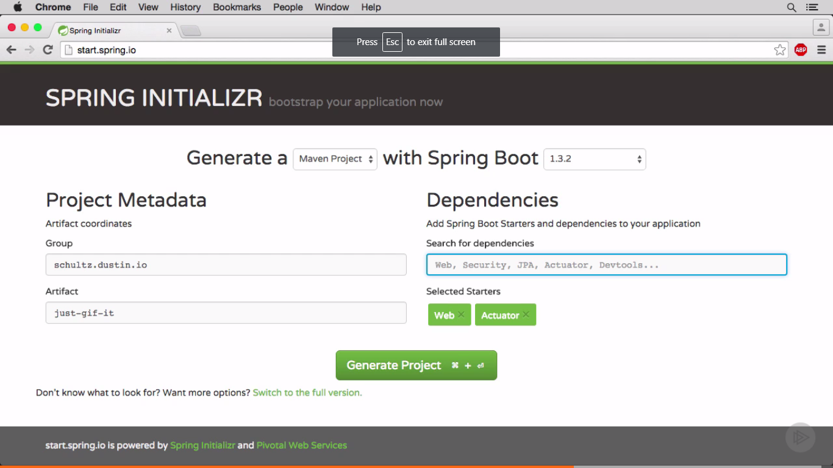

Generate Project and start using the project from zip.

Latest version is 2.0.1 as on 15th March 2018.

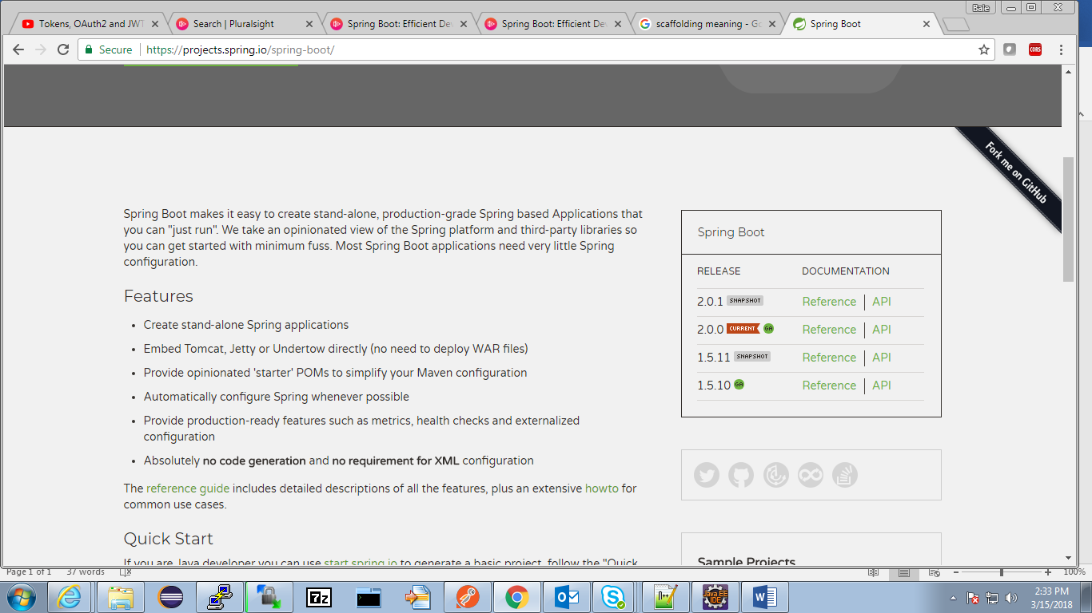

Download curl for windows and extract the first file from the .cab (cabinet) to a suitable location (D:/softwares/). Open cmd prompt at that location and type cmd curl. Use this

|  |  |  |  |  |  |
| --- | --- | --- | --- | --- | --- |
| Win64 x86_64 CAB | [7.59.0](https://skanthak.homepage.t-online.de/download/curl-7.59.0.cab) | **binary** | SSL |  | [Stefan Kanthak](https://skanthak.homepage.t-online.de/curl.html) |

Type the command – it is optional and per your preference

Curl start.spring.io

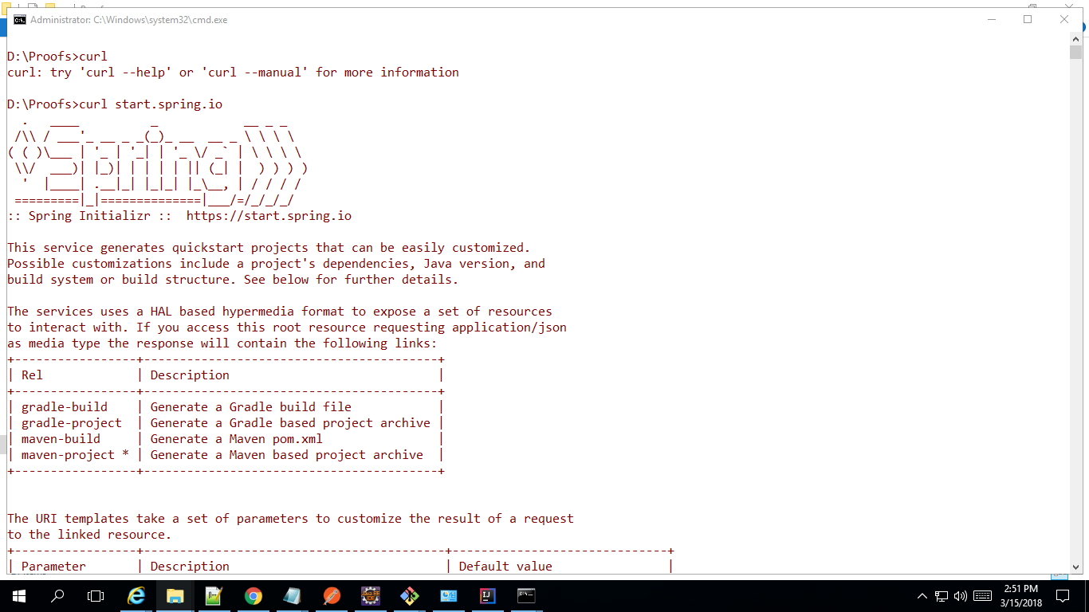

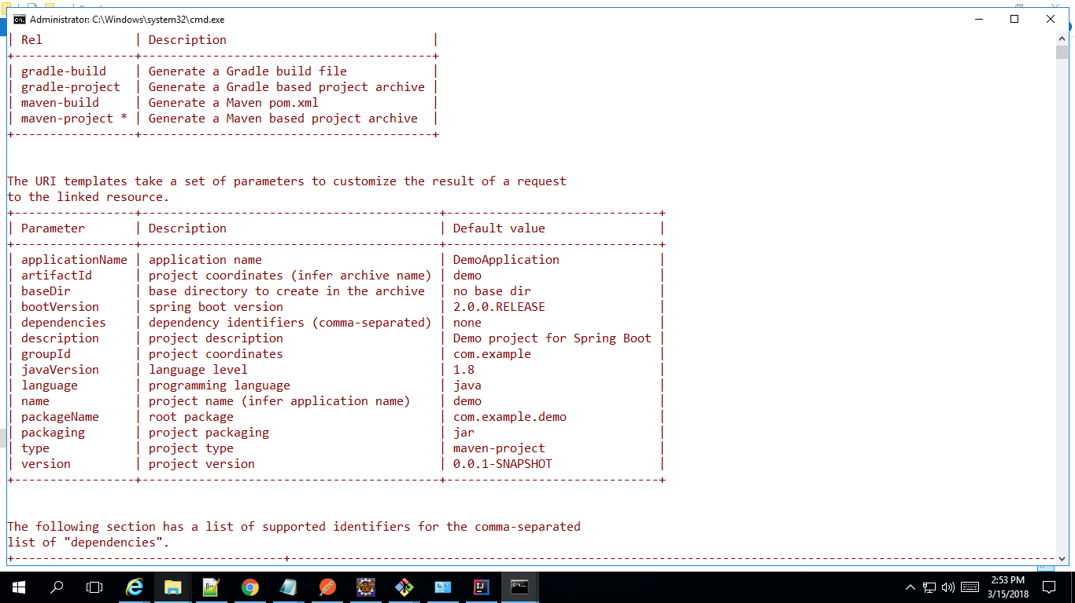

The URI templates take a set of parameters to customize the result of a request

to the linked resource.

+-----------------+------------------------------------------+------------------------------+

| Parameter | Description | Default value |

+-----------------+------------------------------------------+------------------------------+

| applicationName | application name | DemoApplication |

| artifactId | project coordinates (infer archive name) | demo |

| baseDir | base directory to create in the archive | no base dir |

| bootVersion | spring boot version | 2.0.0.RELEASE |

| dependencies | dependency identifiers (comma-separated) | none |

| description | project description | Demo project for Spring Boot |

| groupId | project coordinates | com.example |

| javaVersion | language level | 1.8 |

| language | programming language | java |

| name | project name (infer application name) | demo |

| packageName | root package | com.example.demo |

| packaging | project packaging | jar |

| type | project type | maven-project |

| version | project version | 0.0.1-SNAPSHOT |

+-----------------+------------------------------------------+------------------------------+

You can also bootstrap the project using cmd line – instead of start.spring.io UI

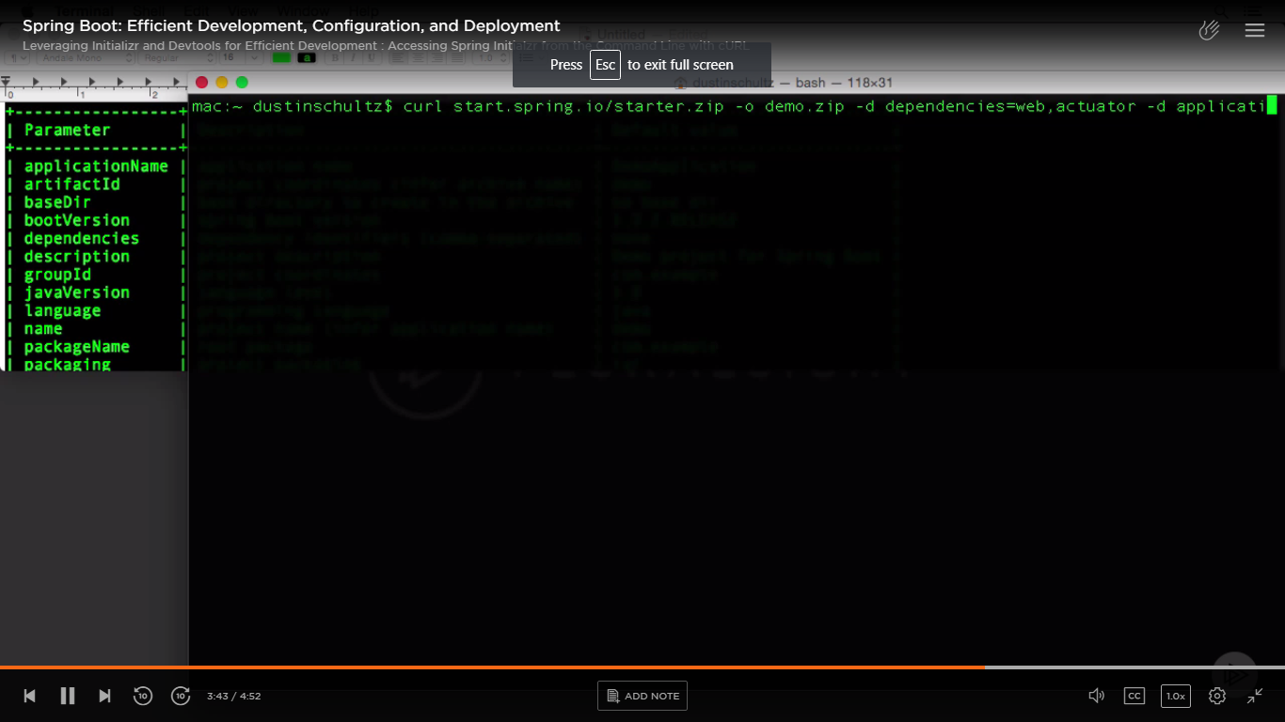

When the number of –d (data) parameters grow in number; it is better to pass it through a file as follows –

Create a file -

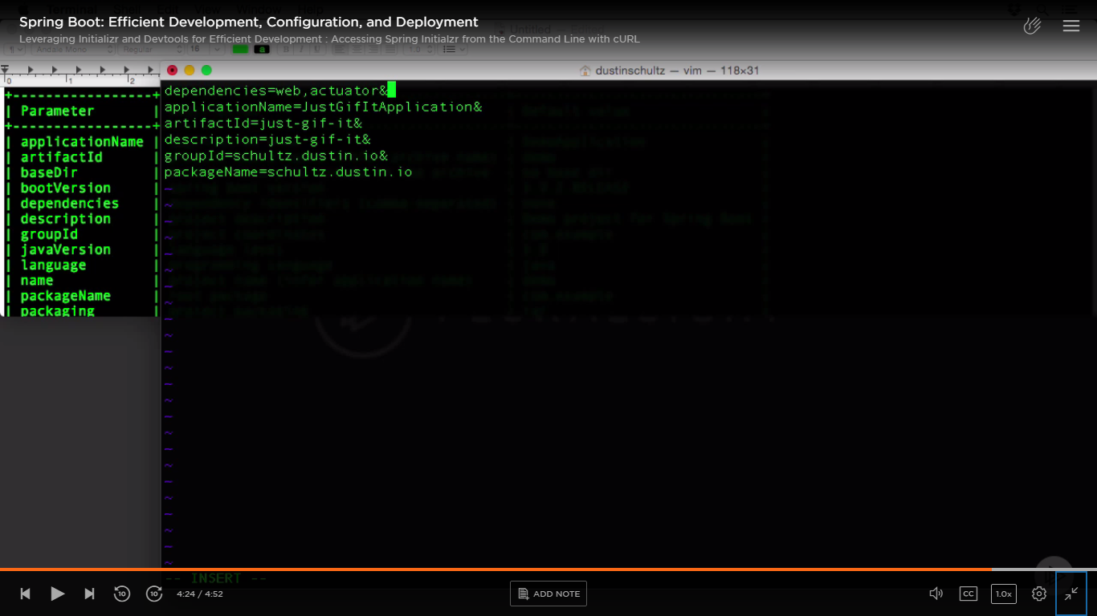

Pass it to curl command -

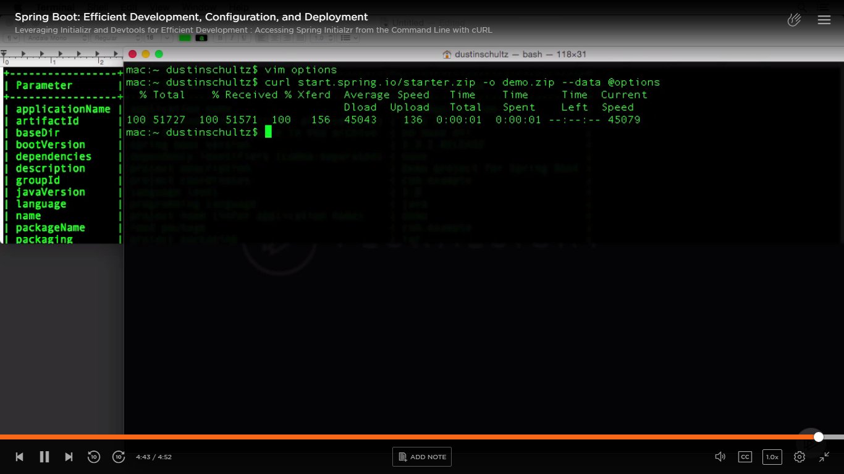

It makes a http request/ call to start.spring.io with those data (--data) and options (-o); then creates our file (demo.zip).

Import this project in Eclipse as existing maven project.

Create a new package called “controller” and create a class inside it – UploadController.java

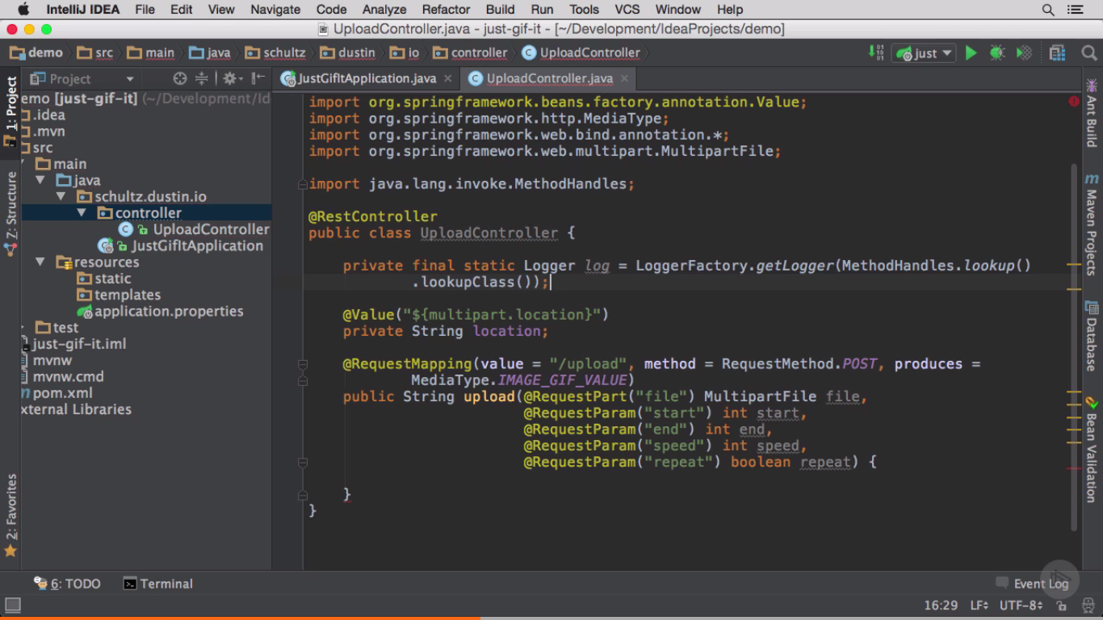

Add required properties in application.properties file –

SB support in IntelliJ, Eclipse and STS provides auto-completion feature and also provides type safety for them. All (standard) properties are backed by java classes.

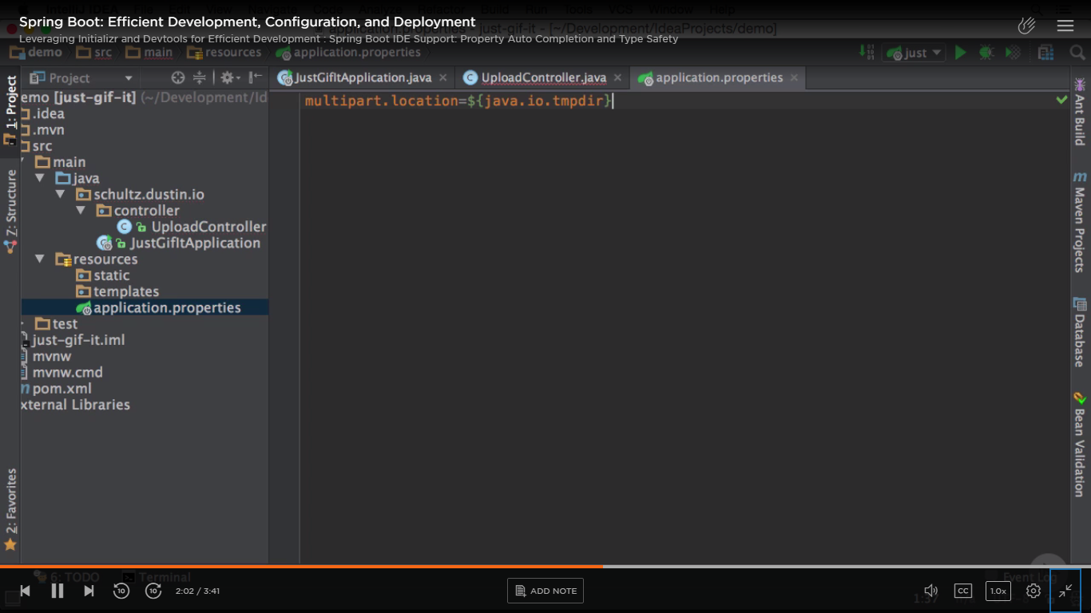

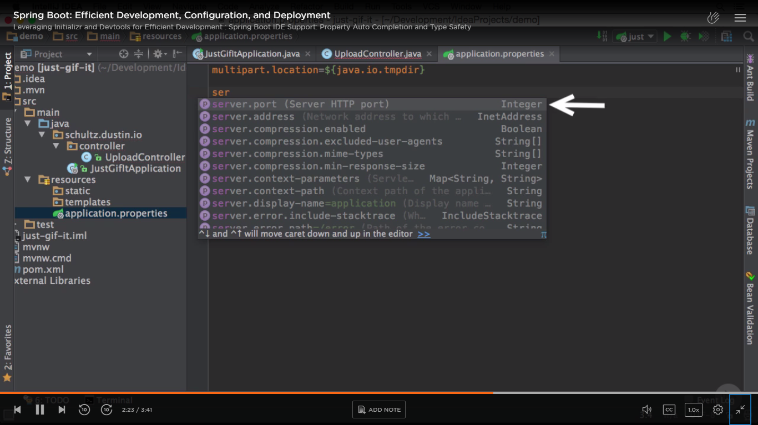

Gives errors if wrong value given for Integer property etc.

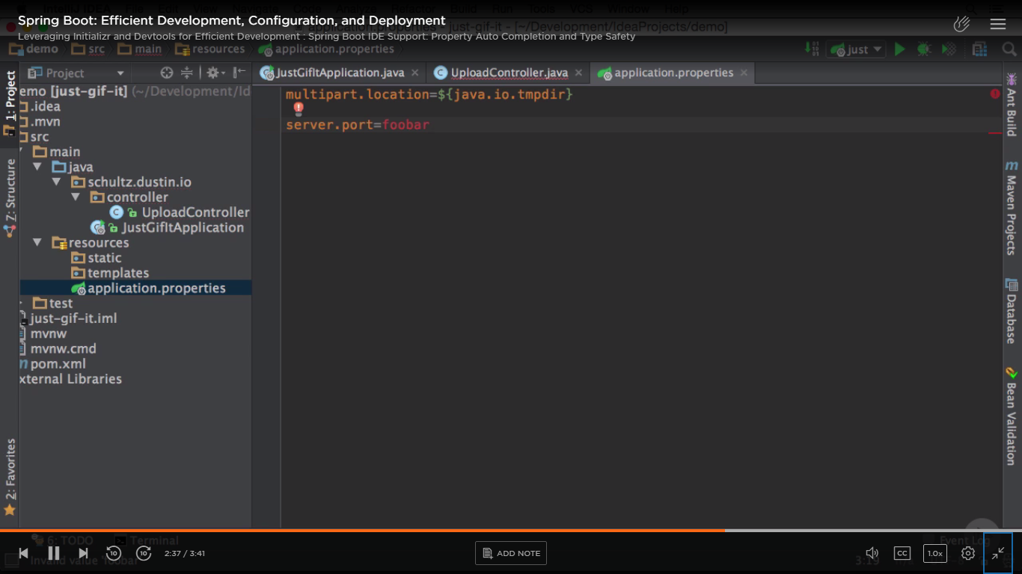

For any SB related property, if you highlight any property and go to View -> Quick Documentation

shows Javadoc for it.

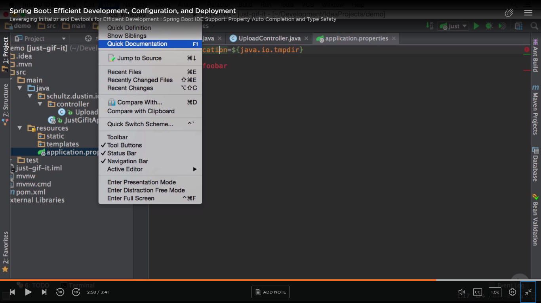

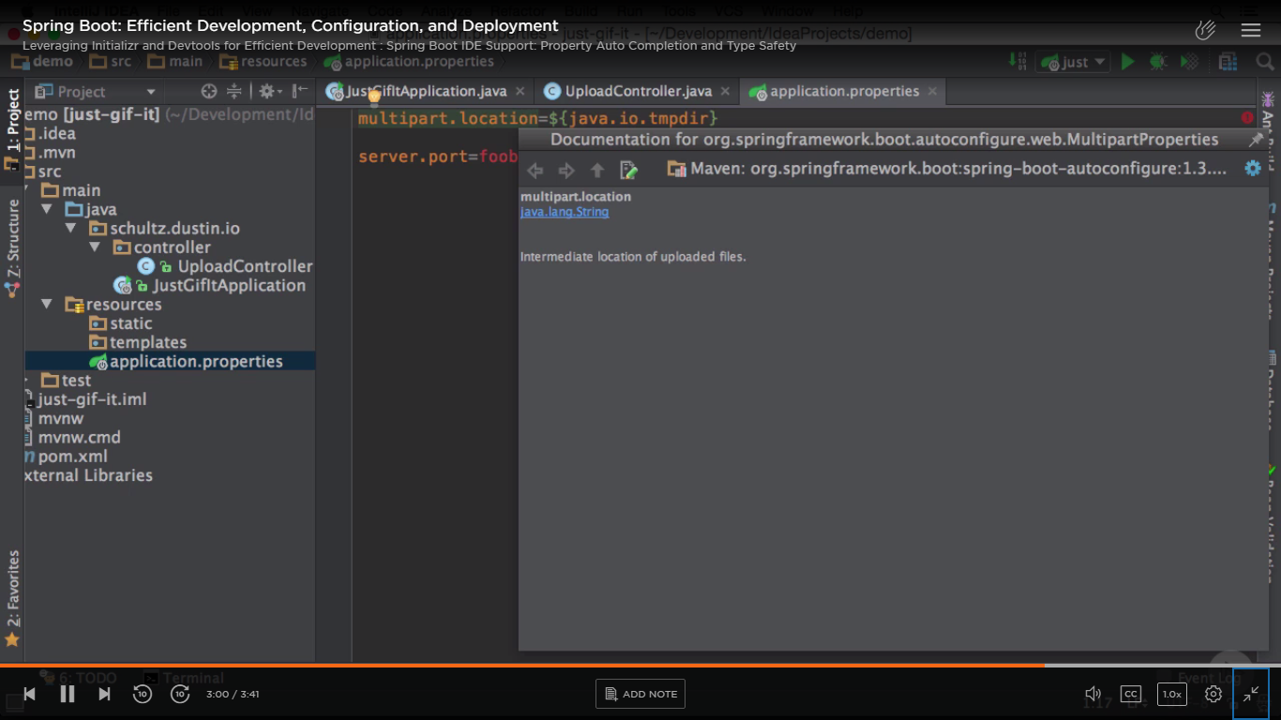

SB properties are backed by Java classes

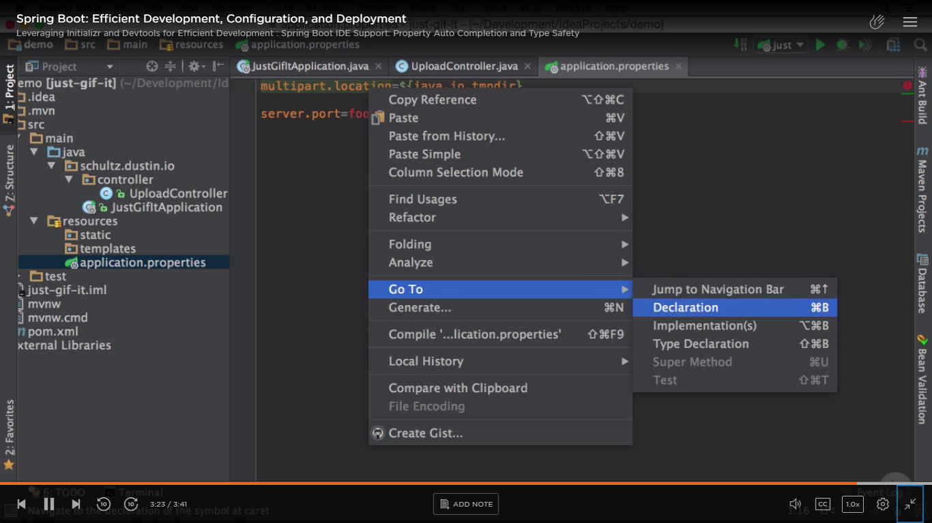

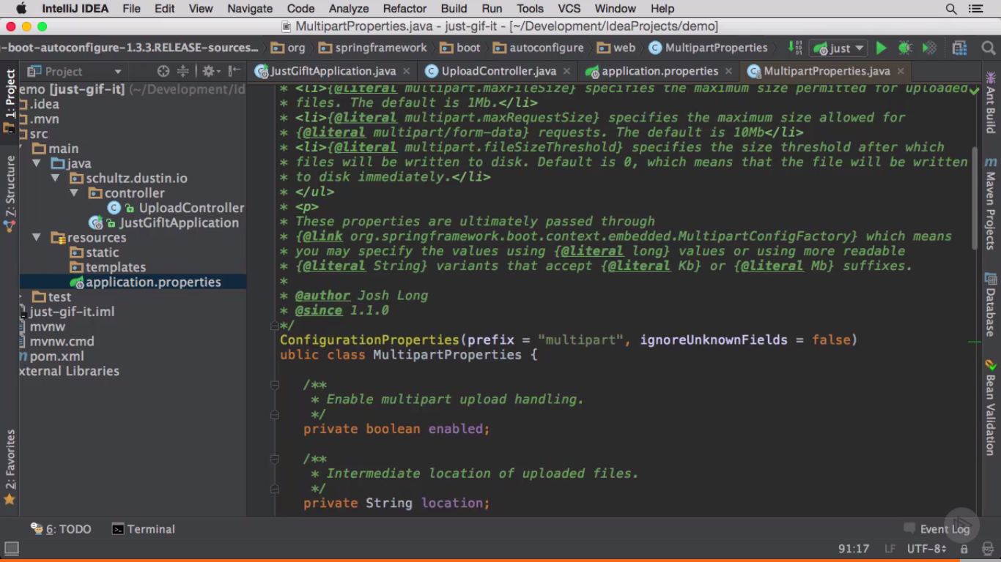

Get the details about what that property means-

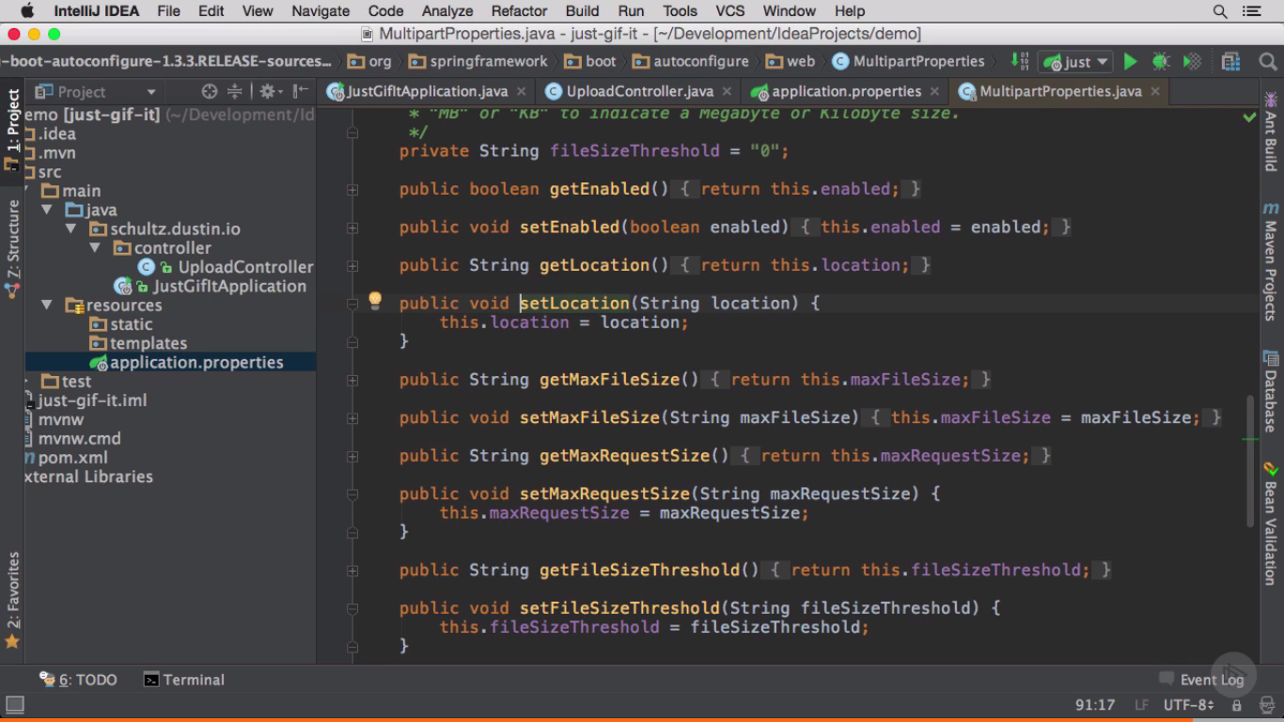

Write business logic for GIF app -

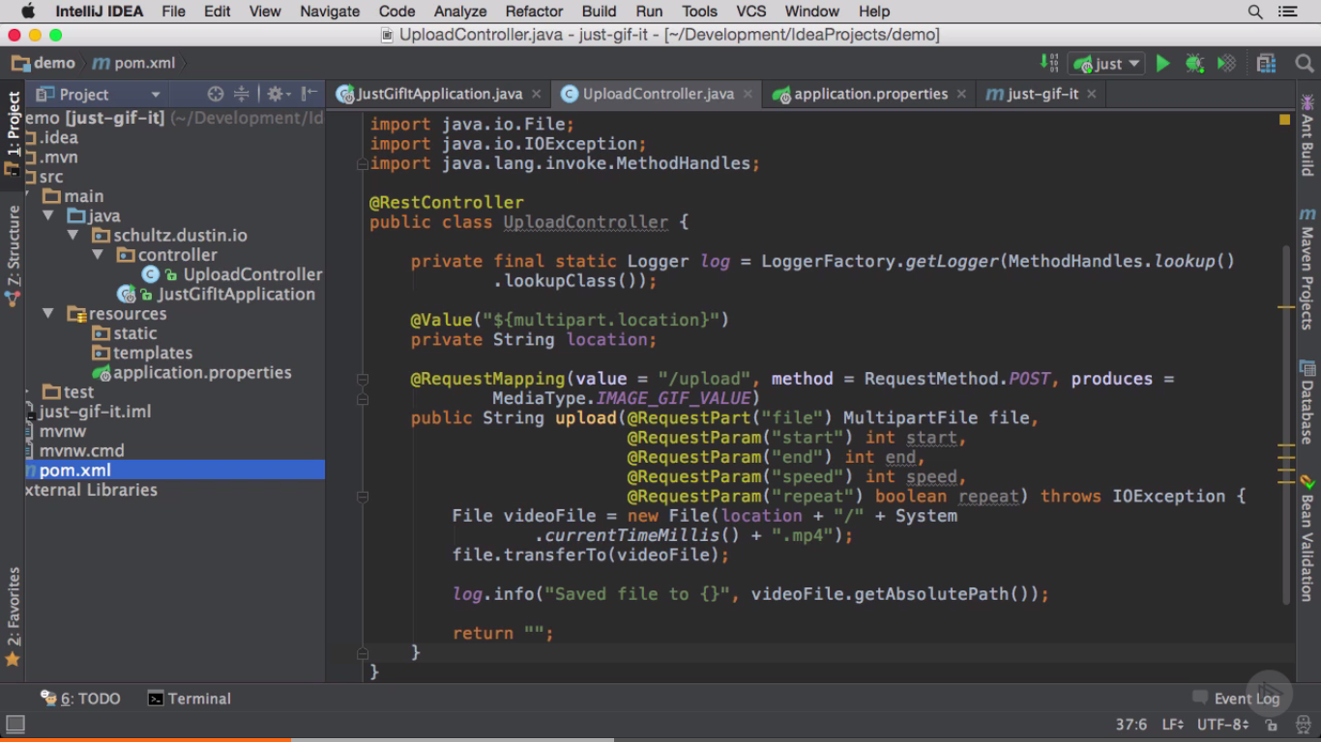

You can create Run Configurations for your SB project in IntelliJ and STS.

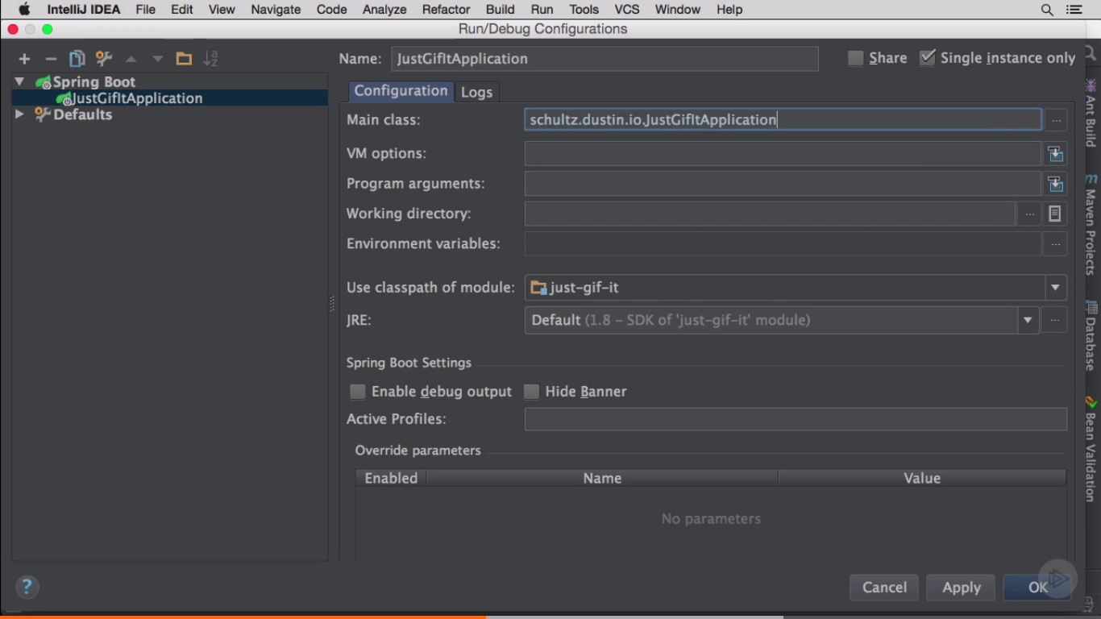

SB Settings and override parameters -

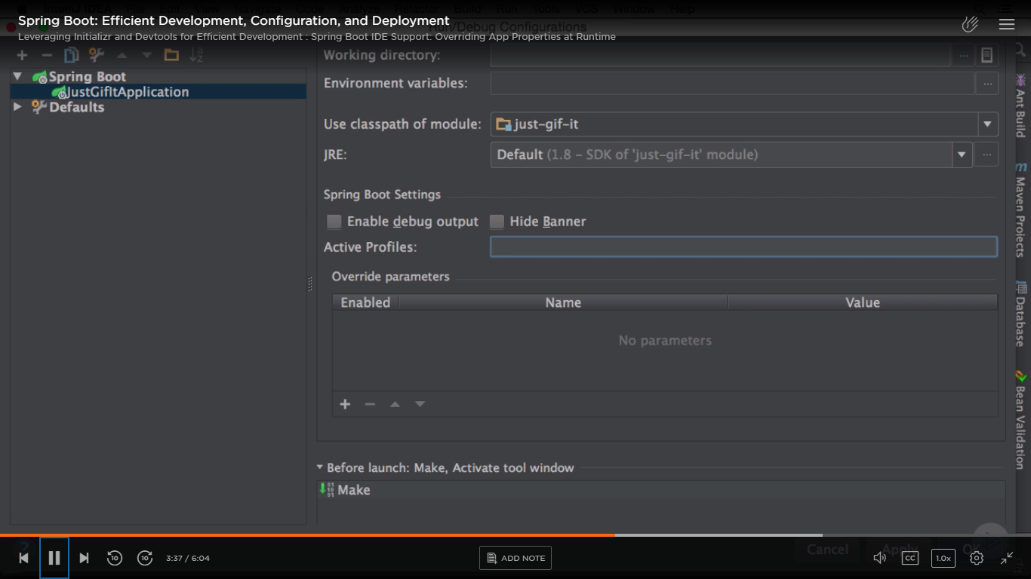

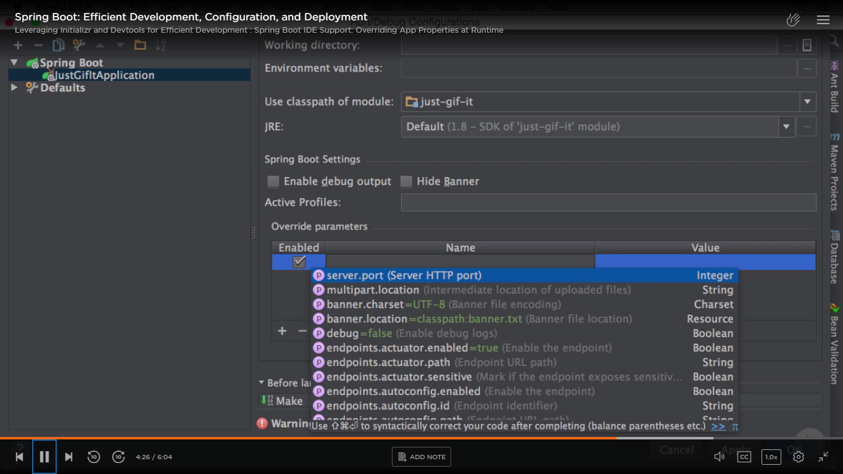

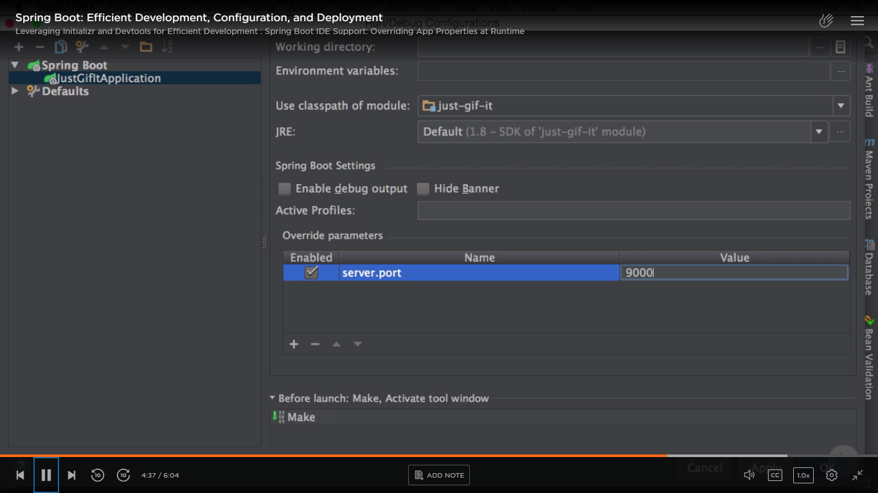

In STS –

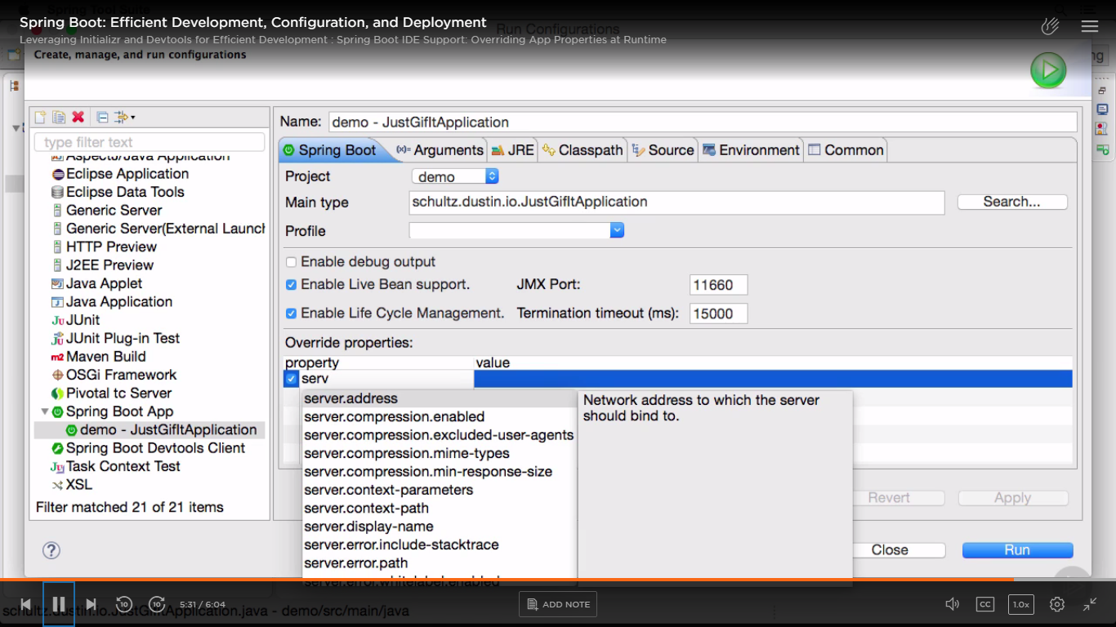

Now start the app -

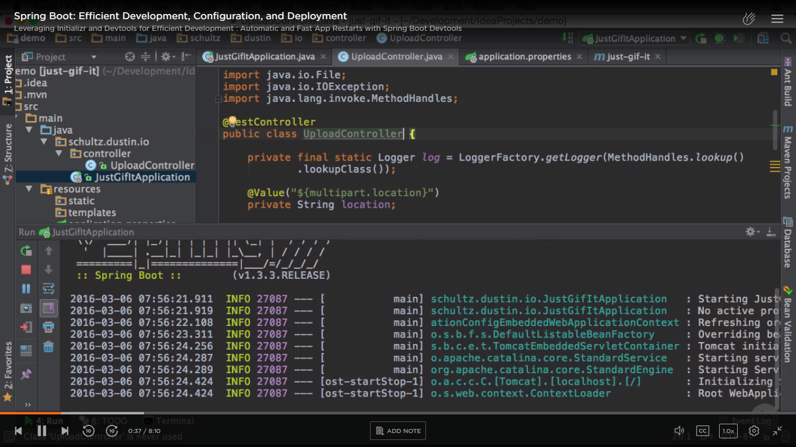

Go to terminal in IntelliJ or curl it from cmd prompt -

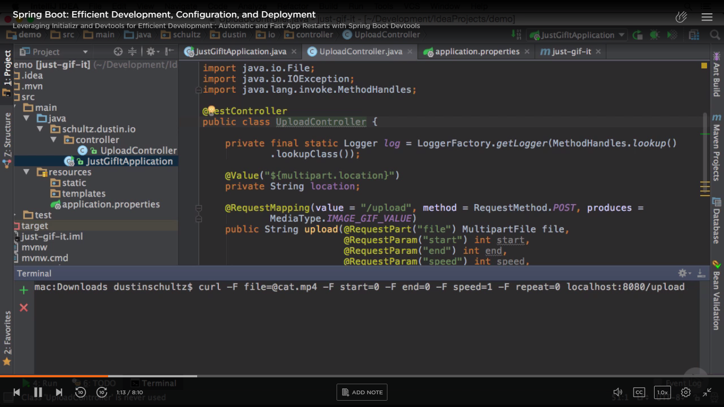

Here each –F param represents a method parameter for upload().

Enter.

If you get a broken pipe exception for size – add below 2 properties in application.properties -

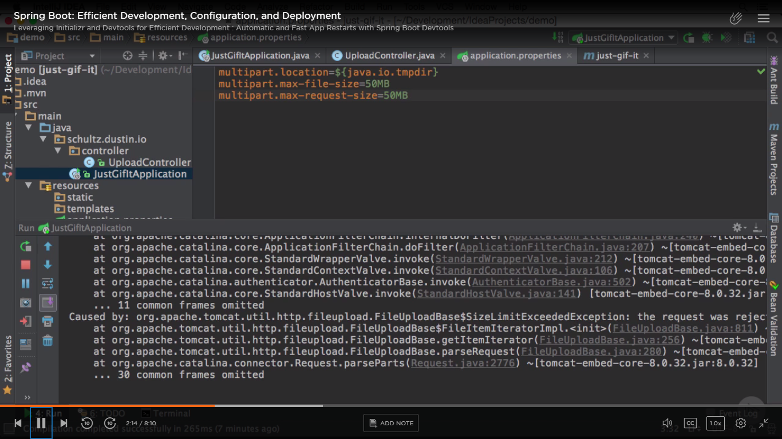

Restart your application and it should be successful.

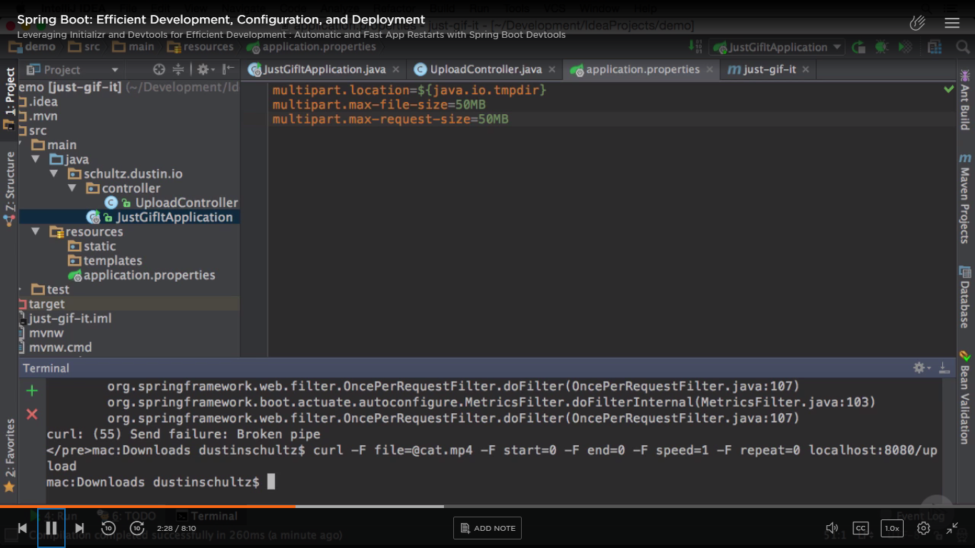

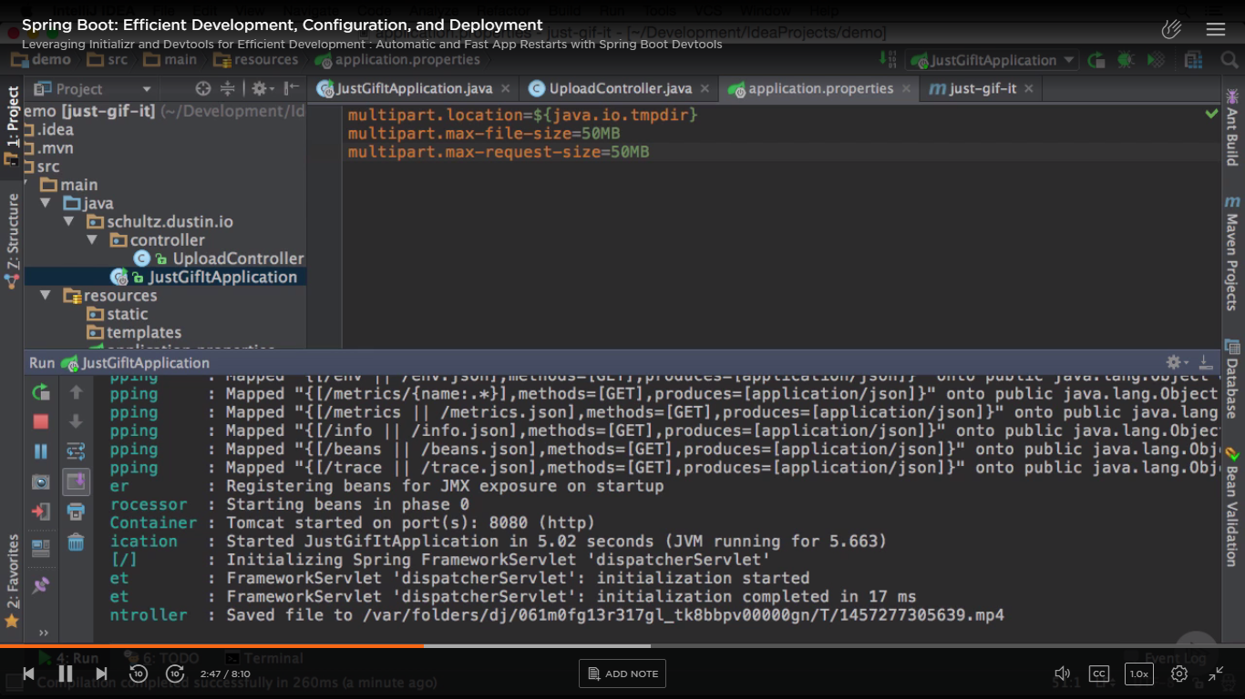

From Spring boot dev tools make it very quick restart cycle (1.3 onwards). Add this optional dependency. In prod, dev tools disables any sort of functionality that is not for prod with help of which class loader is used to load it (like this dev tool).

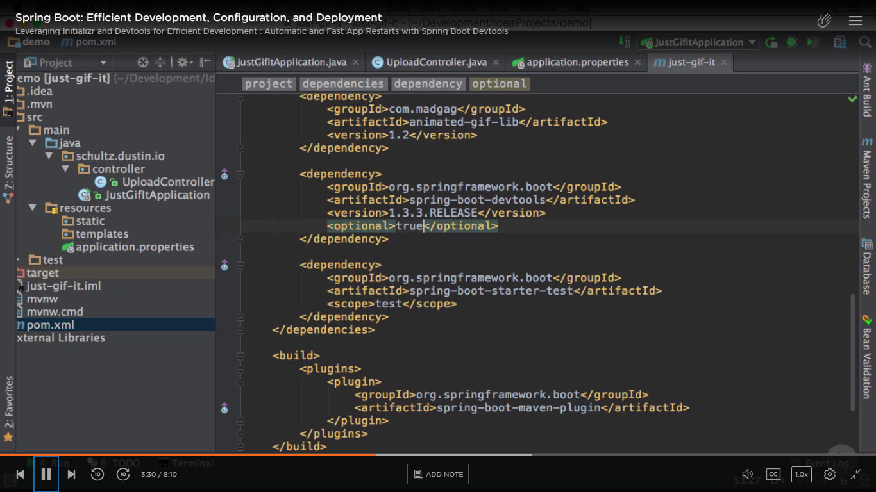

You can add macros in IntelliJ for rapid development. It will automatically builds as soon as you Save a file. Eclipse and STS (I think) has in built.

Now create a new “service” package –

Add the below 3 service classes –

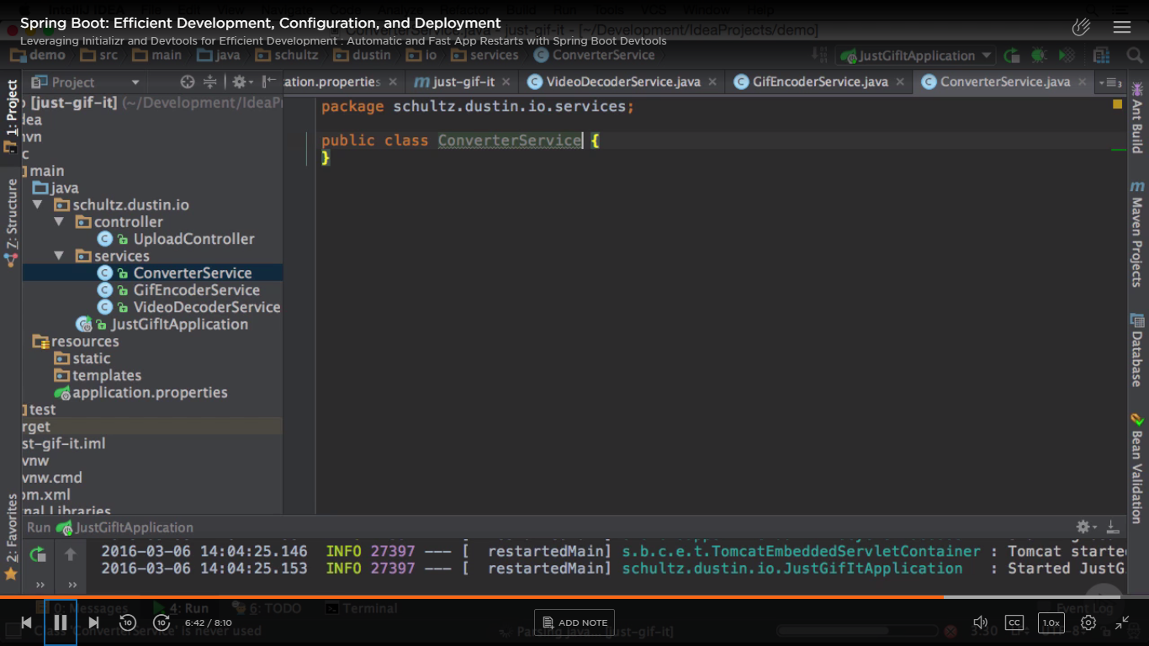

Observe tomcat restarted in 1.19 sec.

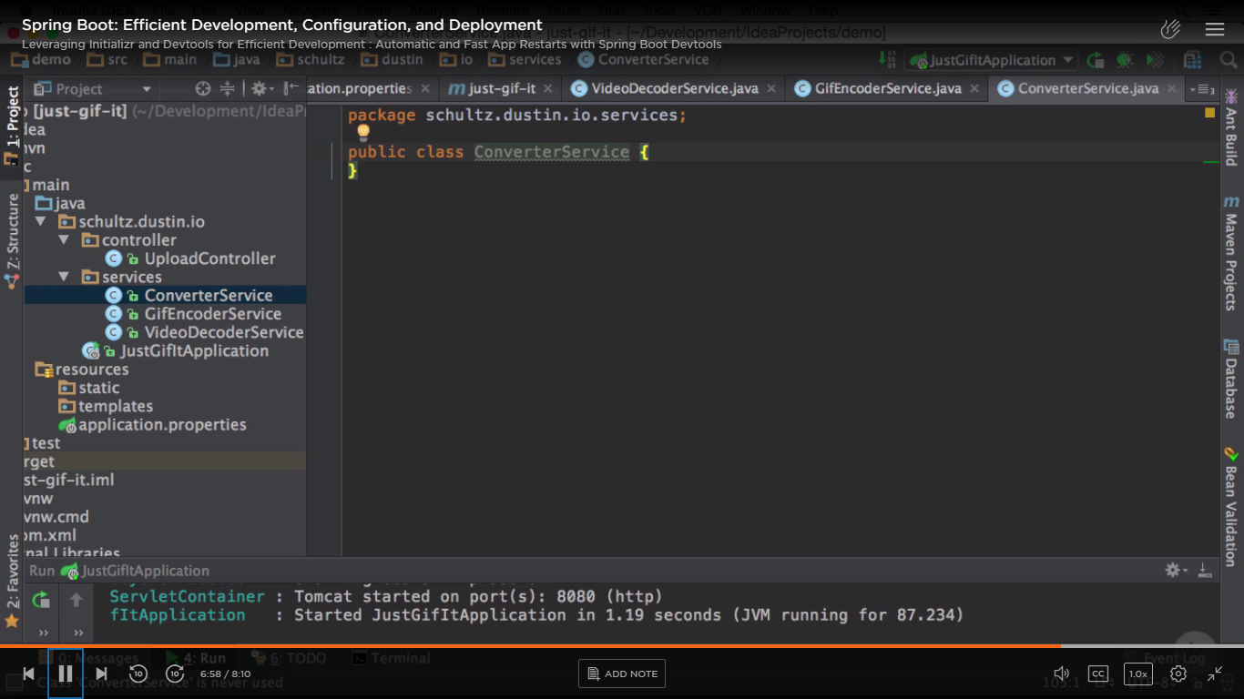

Github url -

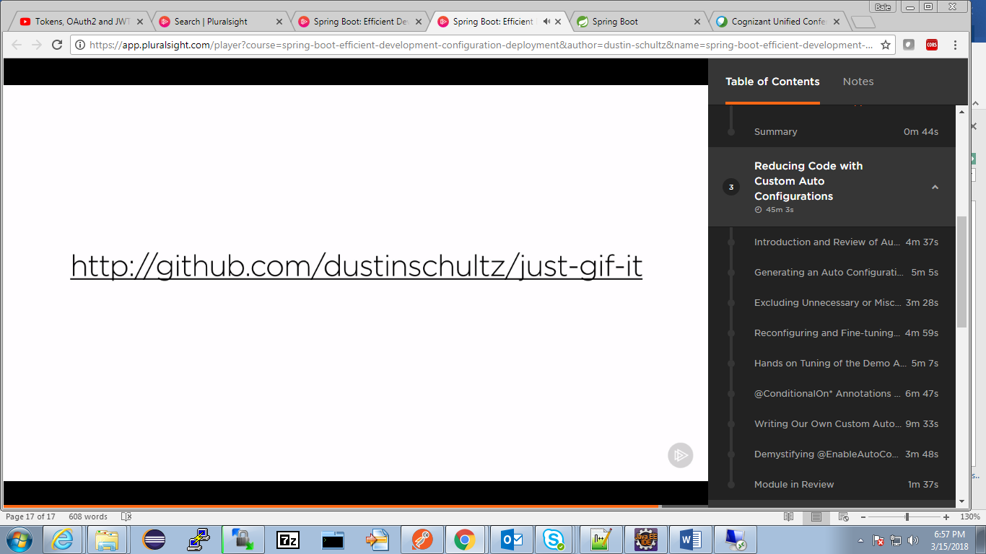

Run -

